INTERCONNECTION NETWORKS

An interconnection network is used for exchanging data between two processors in a multistage network. In case of multiprocessor systems, the performance will be severely affected in case the data exchange between processors is delayed.

The processors can access data from memory associated with another processor or from shared memory using an interconnection network.

Thus, interconnection networks play a central role in determining the overall performance of the multiprocessor systems. The interconnection network is placed between various devices in the multiprocessor network.

VARIOUS INTERCONNECTION NETWORKS

Fully connected:

This is the most powerful interconnection topology. In this each node is directly connected to all other nodes. The shortcoming of this network is that it requires too many connections



Cross Bar:

The crossbar network is the simplest interconnection network. It has a two dimensional grid of switches. It is a non-blocking network and provides connectivity between inputs and outputs and it is possible to join any of the inputs to any output.



Linear Array:

This is a most fundamental interconnection pattern. In this processors are connected in a linear one-dimensional array. The first and last processors are connected with one adjacent processor and the middle processing elements are connected with two adjacent processors. It is a one-dimensional interconnection network.



Mesh:

It is a two dimensional network. In this all processing elements are arranged in a two dimensional grid

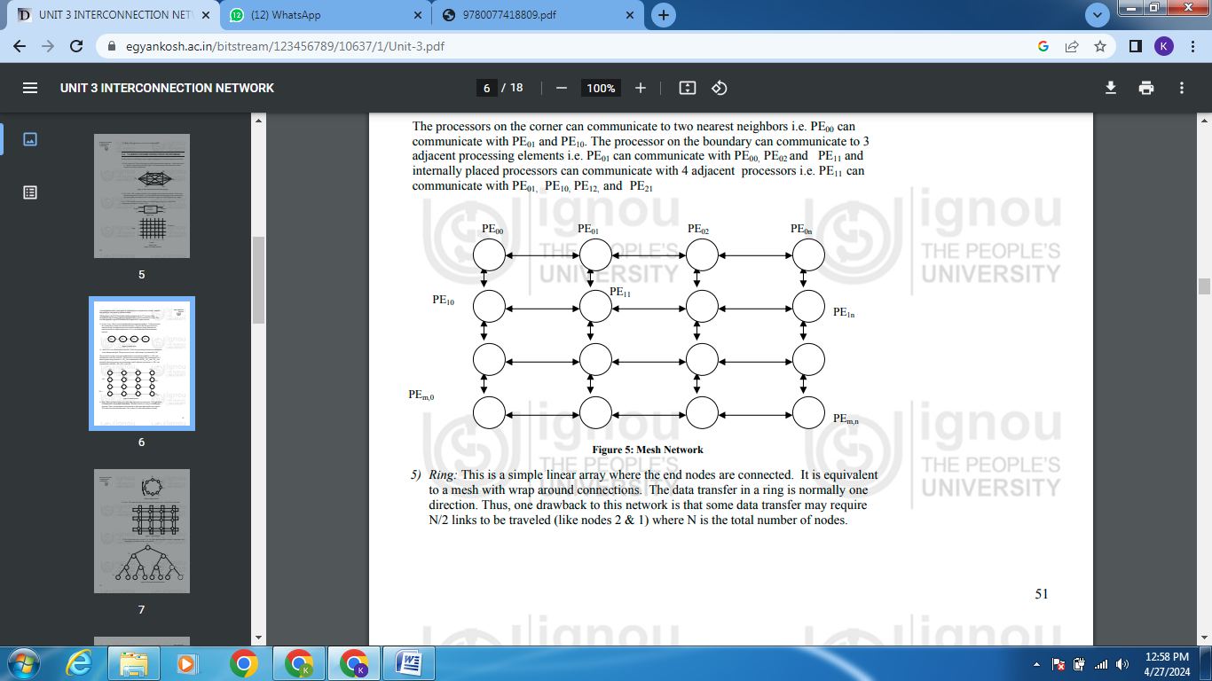

Ring:

This is a simple linear array where the end nodes are connected. It is equivalent to a mesh with wrap around connections. The data transfer in one direction



Torus:

The mesh network with wrap around connections is called Tours Network.



Tree interconnection network

In the tree interconnection network, processors are arranged in a complete binary tree pattern.

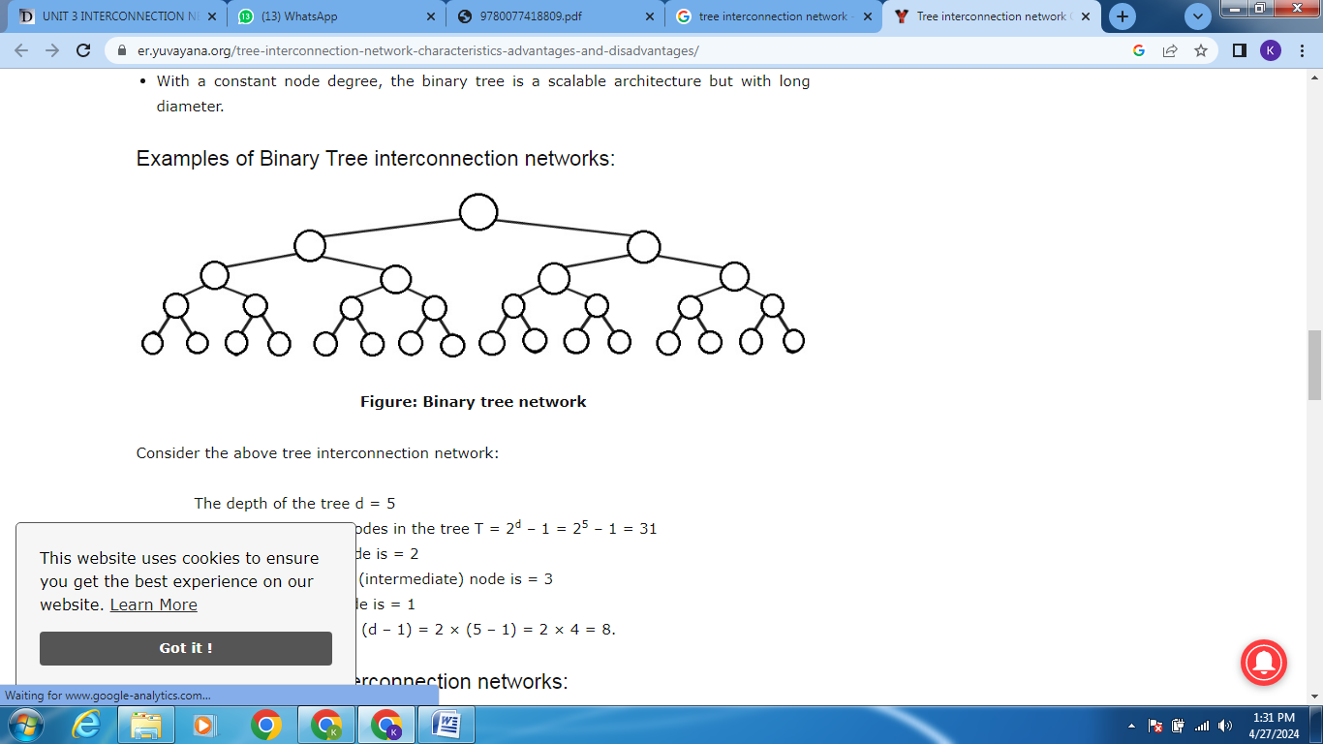

Fat tree:

It is a modified version of the tree network. In this network the bandwidth of edge (or the connecting wire between nodes) increases towards the root. It is a more realistic simulation of the normal tree where branches get thicker towards root.



Systolic Array

This interconnection network is a type of pipelined array architecture and it is designed for multidimensional flow of data. It is used for implementing fixed algorithms



Cube:

It is a 3 dimensional interconnection network. In this the PE’s are arranged in a cube structure

